|  |  |
| --- | --- |
| **Central Station Würzburg** (Würzburg Hauptbahnhof), Bahnhofsplatz | **Streetcars 1,2,3,4,5-** If you want to get from the train station in Würzburg to the Conference Venue at Juliusspital, you can take any streetcar and get off at the stop “Juliuspromenade". |
| **Conference Venue** – Gardenpavillon Juliusspital, Klinikstraße 1, 97070, Würzburg | **Taxi rank** |
|  |  |
| **Train station Würzburg ↔ Pavillon Juliusspital** | |

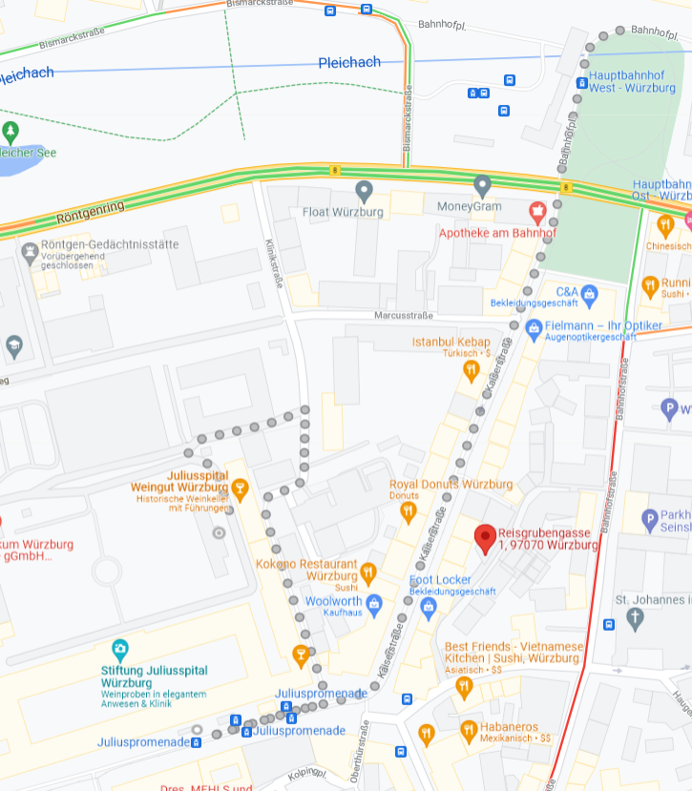

Streetcar **1,2,3,4,5 → 3 min to streetcar station “Juliuspromenade”**

**From there 2 min by foot to Klinikstrasse 1 (garden pavilion)**



