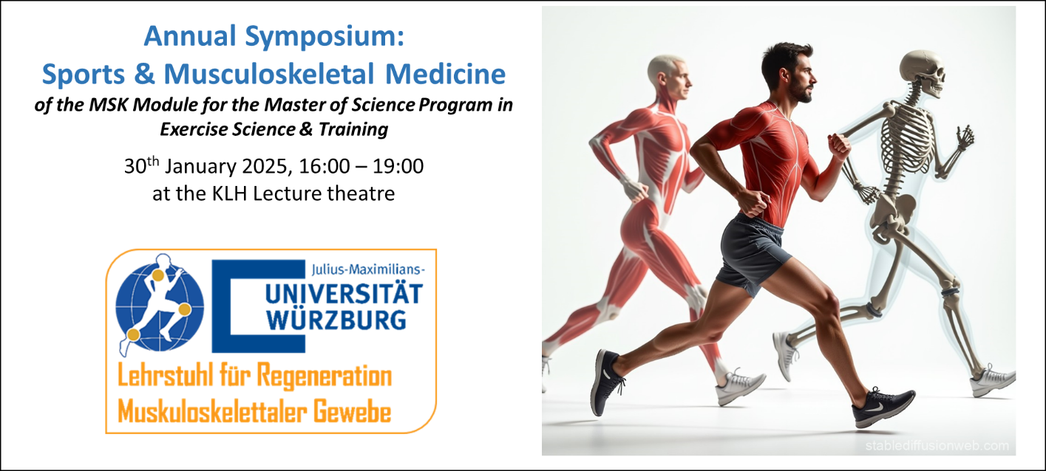

**KLH Website**

The Department for Musculoskeletal Tissue Regeneration of the Orthopaedic Hospital König-Ludwig-Haus (Chairs: Prof. Dr. Denitsa Docheva and Prof. Maximillian Rudert) are hosting the 1st Annual Symposim on Sports & Musculoskeletal Medicine on 30th January, 16:00 – 19:00 at the KLH Lecture Theatre. This is part of the Module on Musculoskeletal tissues, pathologies and adaptation to sports in the International MSc Program in Exercise Science and Training. This symposium is organised by the module tutors, Prof. Denitsa Docheva, Prof. Regina Ebert and Dr. Girish Pattappa. It brings together clinicians and scientists involved in musculoskeletal research with a focus on sports injury, prevention, medicinal therapies and rehabilitation.

The symposium’s distinguished keynote speakers are local, from the KLH and UKW Würzburg - Dr. Stefan Reppenhagen, Dr. Leonard Achenbach, Prof. Franziska Jundt and Prof. Jürgen Groll, as well as external - Prof. Kirsten Legerlotz (Berlin), Dr. Evi Wezenbeek (Ghent, Belgium) and Prof. Peter Angele (Regensburg). In their presentations, various topics covering sports-related musculoskeletal tissue injury, today’s therapeutic strategies, rehabilitation and latest regenerative technologies will be covered. Following the insightful scientific update, guests will have the opportunity to continue vivid discussion with the presenters and to enjoy some beverages and snacks.

The symposium flyer is given below and MSc, GSLS students and other guests are welcomed.